LAB EXPERIMENTS
1.Create a new process by invoking the appropriate system call. Get the process identifier of the currently running process and its respective parent using system calls and display the same using a C program.

AIM
Create a new process by invoking the appropriate system call. Get the process identifier of the currently running process and its respective parent using system calls and display the same using a C program.
ALGORITHM:
1. Start.
2.Declare a variable to store the child process ID.
3. Call fork() to create a new process.
4. If fork() returns a negative value, display an error and stop.
5. If fork() returns 0, the current process is the child:
- Call getpid() to get the child’s process ID.
- Call getppid() to get its parent’s process ID.
- Display both IDs.
6. Otherwise, the current process is the parent:
- Call getpid() to get the parent’s process ID.
- Call getppid() to get its parent’s process ID.
- Display both IDs.
- Call wait() or waitpid() so the parent waits for the child to finish.
7. Stop.
PROGRAM:
#include <stdio.h>
#include <unistd.h>
#include <sys/wait.h>
int main(void) {
pid_t pid = fork();
if (pid < 0) {
perror("fork");
return 1;
}

printf("%s: PID = %d, Parent PID = %d\n",
pid == 0 ? "Child" : "Parent",
getpid(), getppid());
if (pid > 0)
wait(NULL);

return 0;
}
OUTPUT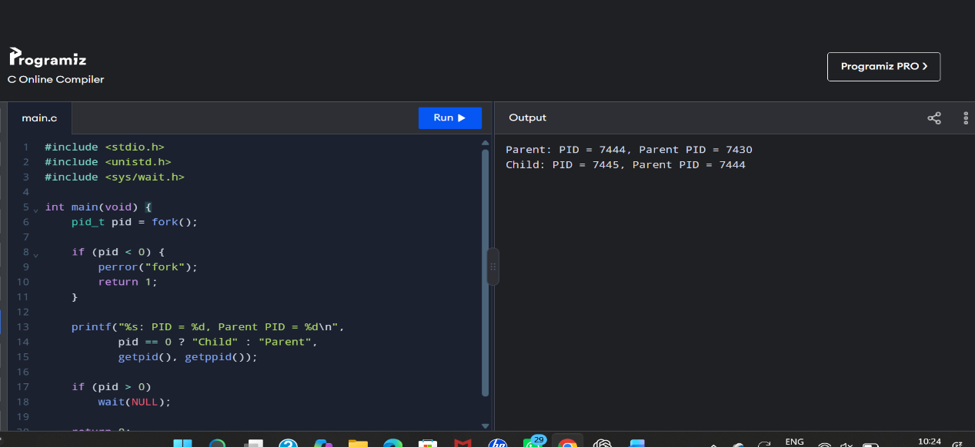

RESULT
The program creates a child process and displays the process ID and parent process ID for both the parent and child. The numeric IDs vary each time it runs.

2. Identify the system calls to copy the content of one file to another and illustrate the same using a C program

AIM
To copy the contents of one file to another using the open(), read(), write(), and close() system calls.
ALGORITHM
1. Open the source file for reading.
2. Open or create the destination file for writing.
3. Repeatedly read data from the source and write it to the destination.
4. Close both files.

PROGRAM

#include <stdio.h>
#include <fcntl.h>
#include <unistd.h>
int main()
{
int source, destination;
char buffer[100];
ssize_t n;

source = open("input.txt", O_RDONLY);

if (source == -1)
{
perror("open input.txt");
return 1;
}

destination = open("output.txt",
O_WRONLY | O_CREAT | O_TRUNC, 0644);

if (destination == -1)
{
perror("open output.txt");
close(source);
return 1;
}

while ((n = read(source, buffer, sizeof(buffer))) > 0)
{
ssize_t total = 0;

while (total < n)
{
ssize_t written = write(destination,
buffer + total, n - total);

if (written <= 0)
{
perror("write");
close(source);
close(destination);
return 1;
}

total += written;
}
}
close(source);
close(destination);
if (n < 0)
{
perror("read");
return 1;
}
printf("File copied successfully!\n");
return 0;
}
OUTPUT
File copied successfully!
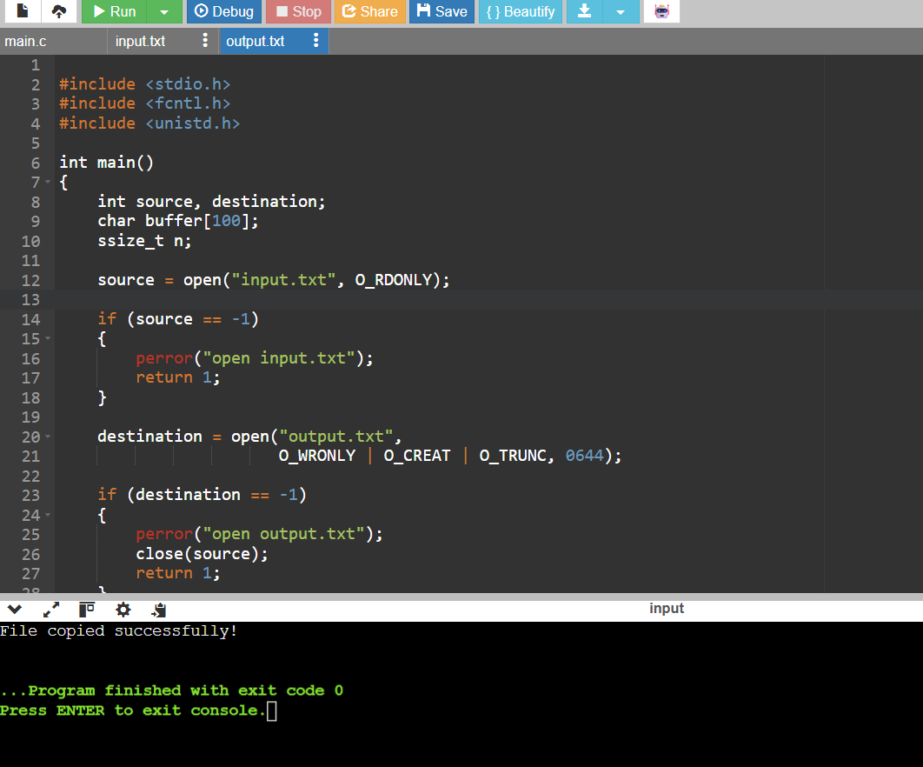

RESULT:
Thus, the contents of one file were successfully copied to another file using the system calls open(), read(), write(), and close() in C.

3. Implement the producer-consumer problem with buffer management using c program

AIM
To implement the Producer-Consumer problem using a shared buffer in C.

ALGORITHM
- Start the program.
- Initialize the buffer, mutex, and semaphores.
- The producer adds items to the buffer.
- The consumer removes items from the buffer.
- Synchronize access to prevent buffer overflow and underflow.
- Stop the program.
PROGRAM

#include <semaphore.h>

sem_t empty, full;

int buffer;

void *producer(void *p) {

sem_wait(&empty);

buffer = 10;

printf("Produced: %d\n", buffer);

sem_post(&full);

return NULL;

}

void *consumer(void *p) {

sem_wait(&full);

printf("Consumed: %d\n", buffer);

sem_post(&empty);

return NULL;

}

int main() {

pthread_t p, c;

sem_init(&empty, 0, 1);

sem_init(&full, 0, 0);

pthread_create(&p, NULL, producer, NULL);

pthread_create(&c, NULL, consumer, NULL);

pthread_join(p, NULL);

pthread_join(c, NULL);

return 0;

}

OUTPUT
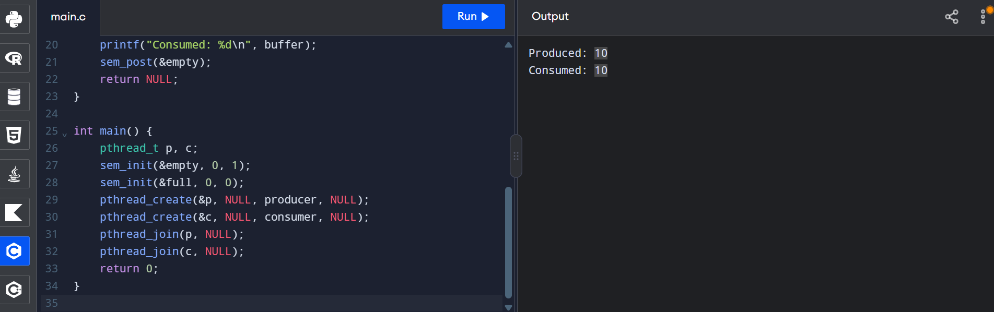
RESULT:
Thus, the Producer-Consumer problem using buffer management, threads, mutex, and semaphores was implemented successfully.

4. Implementation of Client-Server Chatting Using TCP in C

AIM
To write and execute a C program to implement client-server chatting using TCP socket programming.

ALGORITHM
Server program
- Start the program.
- Create a TCP socket using socket().
- Bind the socket to port 8080 using bind().
- Listen for client connections using listen().
- Accept the client connection using accept().
- Send and receive messages using send() and recv().
- Close the socket when the chat ends.
Client program
- Start the program.
- Create a TCP socket.
- Connect to the server using connect().
- Send and receive messages using send() and recv().
- Type exit to end the chat.
- Close the socket.

PROGRAM

Server program (server.c)
#include <stdio.h>
#include <unistd.h>
#include <arpa/inet.h>
int main() {
int s, c;
char b[100];
struct sockaddr_in a = {AF_INET, htons(8080), INADDR_ANY};
s = socket(AF_INET, SOCK_STREAM, 0);
bind(s, (void *)&a, sizeof(a));
listen(s, 1);
c = accept(s, NULL, NULL);
recv(c, b, sizeof(b), 0);
printf("Client: %s\n", b);
send(c, "Hello Client", 12, 0);
close(c);
close(s);
return 0;
}

Client (client.c)
#include <stdio.h>
#include <unistd.h>
#include <arpa/inet.h>
int main() {
int s;
char b[100];
struct sockaddr_in a = {AF_INET, htons(8080)};
s = socket(AF_INET, SOCK_STREAM, 0);
a.sin_addr.s_addr = inet_addr("127.0.0.1");
connect(s, (void *)&a, sizeof(a));
send(s, "Hello Server", 12, 0);
int n = recv(s, b, 99, 0);
b[n] = '\0';
printf("Server: %s\n", b);
close(s);
return 0;
}

OUTPUT
Client:
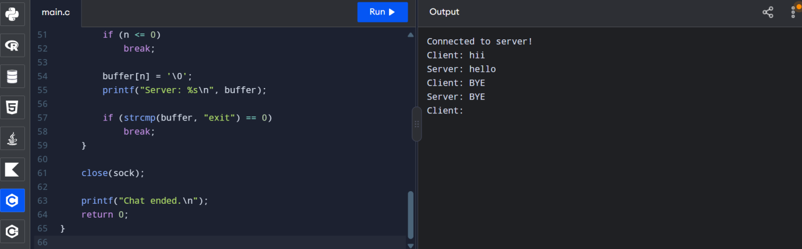

Server:
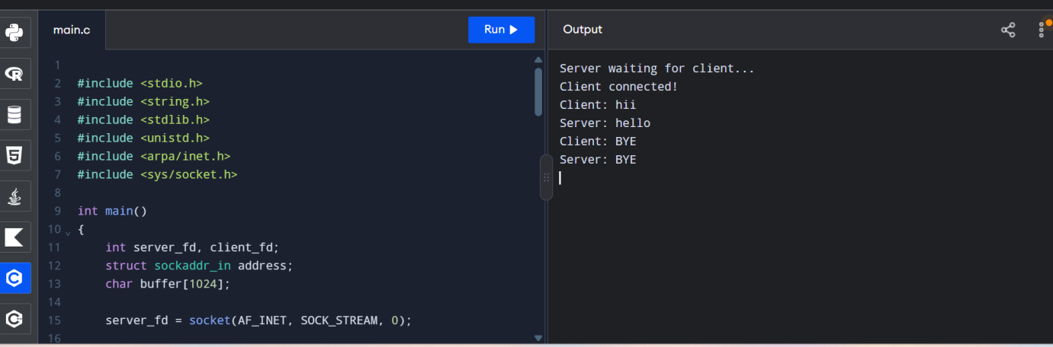
RESULT
Thus, TCP client-server communication in C was implemented successfully. Implement the procedure consumes problem with buffer management using c program.

5. Implementation of Java Programming Using Multithreading

AIM
To write and execute a Java program to implement multithreading using the Thread class.

ALGORITHM
- Start the program.
- Create a class that extends the Thread class.
- Override the run() method to define the task performed by the thread.
- Create two thread objects.
- Start both threads using the start() method.
- Display messages from both threads.
- Stop the program.
PROGRAM
class Multithreading extends Thread
{
public void run()
{
for (int i = 1; i <= 5; i++)
{
System.out.println(
Thread.currentThread().getName() + " : " );
}
}
public static void main(String[] args)
{
Multithreading t1 = new Multithreading();
Multithreading t2 = new Multithreading();
t1.setName("Thread 1");
t2.setName("Thread 2");

t1.start();
t2.start();
}
}
OUTPUT
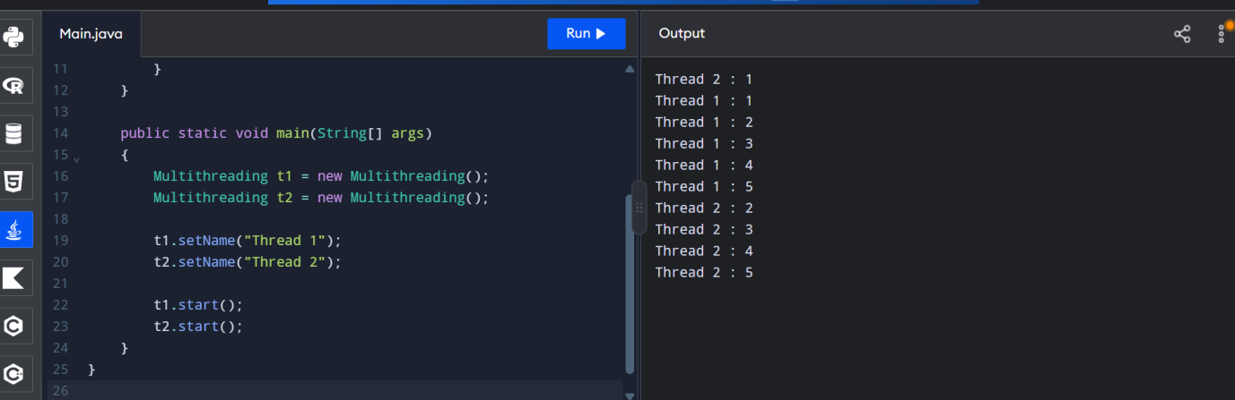

RESULT
Thus, the Java program to implement multithreading using the Thread class was executed successfully.

6. Design a CPU scheduling program with C using First Come First Served technique with the following considerations.
a. All processes are activated at time 0.
b. Assume that no process waits on I/O devices

AIM
To implement CPU scheduling using the First Come First Served (FCFS) technique in C.

ALGORITHM
- Start the program.
- Read the number of processes and their burst times.
- Set the first process's waiting time to zero.
- Calculate the waiting time of each subsequent process.
- Calculate turnaround time using TAT = WT + BT.
- Calculate and display the average waiting time and average turnaround time.
- Stop the program.
PROGRAM
#include <stdio.h>

int main()
{
int n, i;
int bt[20], wt[20], tat[20];
float avg_wt = 0, avg_tat = 0;

printf("Enter number of processes: ");
scanf("%d", &n);

for (i = 0; i < n; i++)
{
printf("Enter burst time for P%d: ", i + 1);
scanf("%d", &bt[i]);
}

wt[0] = 0;

for (i = 1; i < n; i++)
{
wt[i] = wt[i - 1] + bt[i - 1];
}

for (i = 0; i < n; i++)
{
tat[i] = wt[i] + bt[i];
avg_wt += wt[i];
avg_tat += tat[i];
}

avg_wt /= n;
avg_tat /= n;

printf("\nProcess\tBurst Time\tWaiting Time\tTurnaround Time\n");

for (i = 0; i < n; i++)
{
printf("P%d\t%d\t\t%d\t\t%d\n",
i + 1, bt[i], wt[i], tat[i]);
}

printf("\nAverage Waiting Time = %.2f", avg_wt);
printf("\nAverage Turnaround Time = %.2f\n", avg_tat);

return 0;
}

SAMPLE OUTPUT
Enter number of processes: 3
Enter burst time for P1: 5
Enter burst time for P2: 3
Enter burst time for P3: 2

Process Burst Time Waiting Time Turnaround Time
P1 5 0 5
P2 3 5 8
P3 2 8 10

Average Waiting Time = 4.33
Average Turnaround Time = 7.67

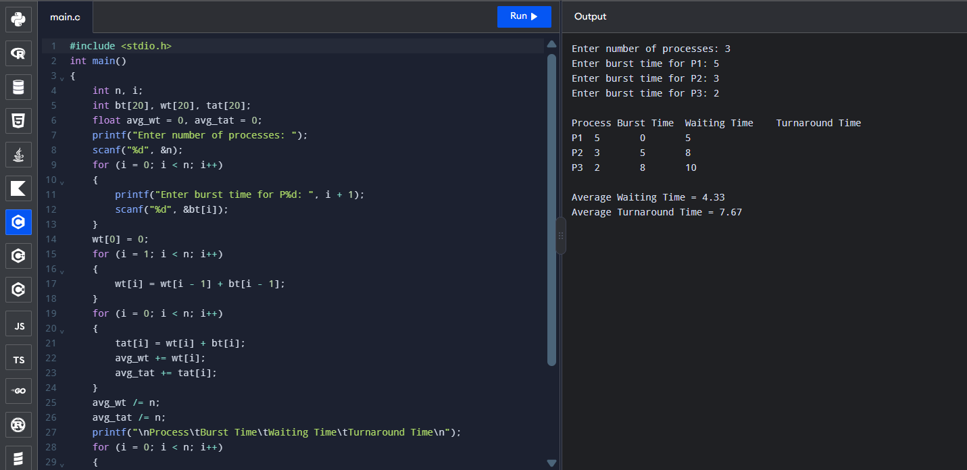

RESULT:
Thus, the C program for CPU scheduling using the First Come First Served (FCFS) technique was successfully executed, and the waiting time, turnaround time, average waiting time, and average turnaround time were calculated.

7.Construct a scheduling program with C that selects the waiting process with the smallest execution time to execute next

AIM
To implement CPU scheduling using the Shortest Job First (SJF) technique in C.

ALGORITHM
- Start the program.
- Read the number of processes and their burst times.
- Sort the processes in ascending order of burst time.
- Set the first process's waiting time to zero.
- Calculate the waiting time and turnaround time for each process.
- Calculate and display the average waiting time and average turnaround time.
- Stop the program.
PROGRAM

#include <stdio.h>

int main()
{
int n, i, j, temp;
int bt[20], wt[20], tat[20], p[20];
float avg_wt = 0, avg_tat = 0;

printf("Enter number of processes: ");
scanf("%d", &n);

for (i = 0; i < n; i++)
{
p[i] = i + 1;
printf("Enter burst time for P%d: ", p[i]);
scanf("%d", &bt[i]);
}

// Sort processes by burst time
for (i = 0; i < n - 1; i++)
{
for (j = i + 1; j < n; j++)
{
if (bt[i] > bt[j])
{
temp = bt[i];
bt[i] = bt[j];
bt[j] = temp;

temp = p[i];
p[i] = p[j];
p[j] = temp;
}
}
}

wt[0] = 0;

for (i = 1; i < n; i++)
wt[i] = wt[i - 1] + bt[i - 1];

for (i = 0; i < n; i++)
{
tat[i] = wt[i] + bt[i];
avg_wt += wt[i];
avg_tat += tat[i];
}

avg_wt /= n;
avg_tat /= n;

printf("\nProcess\tBurst Time\tWaiting Time\tTurnaround Time\n");

for (i = 0; i < n; i++)
printf("P%d\t%d\t\t%d\t\t%d\n",
p[i], bt[i], wt[i], tat[i]);

printf("\nAverage Waiting Time = %.2f", avg_wt);
printf("\nAverage Turnaround Time = %.2f\n", avg_tat);

return 0;
}
SAMPLE OUTPUT
Enter number of processes: 3
Enter burst time for P1: 5
Enter burst time for P2: 3
Enter burst time for P3: 2
Process Burst Time Waiting Time Turnaround Time
P3 2 0 2
P2 3 2 5
P1 5 5 10

Average Waiting Time = 2.33
Average Turnaround Time = 5.67
OUTPUT
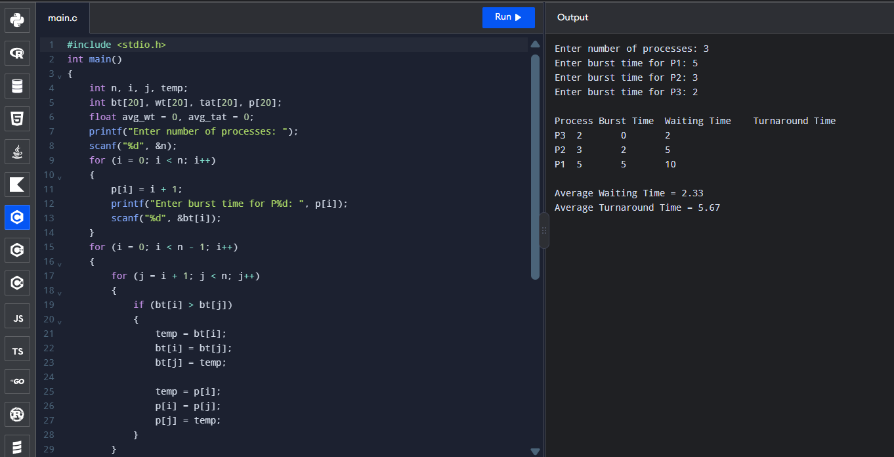
RESULT:
Thus, the C program for Shortest Job First (SJF) CPU Scheduling was successfully executed, and the waiting time and turnaround time of each process were calculated.

8.Construct a scheduling program with C that selects the waiting process with the highest priority to execute next.

AIM
To implement CPU scheduling using the Priority Scheduling technique in C.

ALGORITHM
- Start the program.
- Read the number of processes, burst times, and priorities.
- Sort the processes in ascending order of priority number.
- Calculate the waiting time and turnaround time for each process.
- Calculate the average waiting time and average turnaround time.
- Display the results.
- Stop the program.
PROGRAM

#include <stdio.h>
int main()
{
int n, i, j, temp;
int bt[20], p[20], pr[20], wt[20], tat[20];
float avg_wt = 0, avg_tat = 0;

printf("Enter number of processes: ");
scanf("%d", &n);

for (i = 0; i < n; i++)
{
p[i] = i + 1;
printf("Enter burst time for P%d: ", p[i]);
scanf("%d", &bt[i]);
printf("Enter priority for P%d: ", p[i]);
scanf("%d", &pr[i]);
}

for (i = 0; i < n - 1; i++)
{
for (j = i + 1; j < n; j++)
{
if (pr[i] > pr[j])
{
temp = pr[i];
pr[i] = pr[j];
pr[j] = temp;

temp = bt[i];
bt[i] = bt[j];
bt[j] = temp;

temp = p[i];
p[i] = p[j];
p[j] = temp;
}
}
}

wt[0] = 0;

for (i = 1; i < n; i++)
wt[i] = wt[i - 1] + bt[i - 1];

for (i = 0; i < n; i++)
{
tat[i] = wt[i] + bt[i];
avg_wt += wt[i];
avg_tat += tat[i];
}

avg_wt /= n;
avg_tat /= n;

printf("\nProcess\tBurst Time\tPriority\tWaiting Time\tTurnaround Time\n");

for (i = 0; i < n; i++)
printf("P%d\t%d\t\t%d\t\t%d\t\t%d\n",
p[i], bt[i], pr[i], wt[i], tat[i]);
printf("\nAverage Waiting Time = %.2f", avg_wt);
printf("\nAverage Turnaround Time = %.2f\n", avg_tat);

return 0;
}
Sample Output
Enter number of processes: 3
Enter burst time for P1: 5
Enter priority for P1: 3
Enter burst time for P2: 3
Enter priority for P2: 1
Enter burst time for P3: 2
Enter priority for P3: 2

Process Burst Time Priority Waiting Time Turnaround Time
P2 3 1 0 3
P3 2 2 3 5
P1 5 3 5 10

Average Waiting Time = 2.67
Average Turnaround Time = 6.00

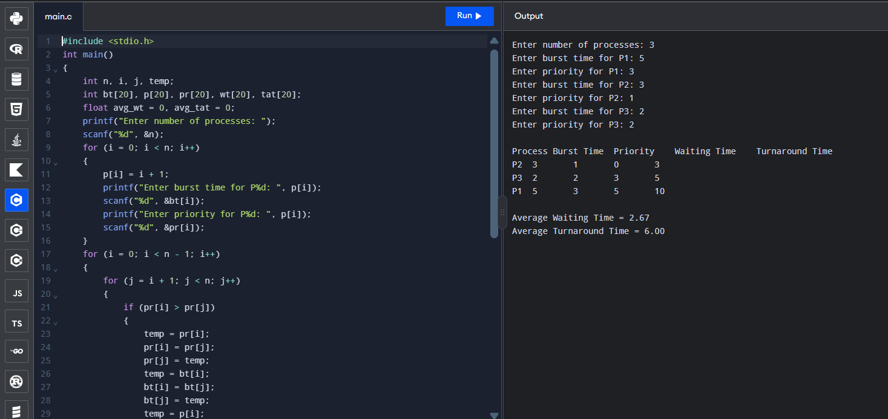

RESULT:
Thus, the C program for Priority CPU Scheduling was successfully executed, and the waiting time and turnaround time were calculated for each process.

9.Construct a C program to simulate Round Robin scheduling algorithm with C.

AIM
To implement the Round Robin CPU Scheduling algorithm using C.
ALGORITHM
- Start the program.
- Read the number of processes and their burst times.
- Read the time quantum.
- Execute each process for the time quantum in circular order.
- Repeat until all processes are completed.
- Calculate and display the waiting time and turnaround time.
- Stop the program.
PROGRAM
#include <stdio.h>
int main()
{
int n, i, tq, time = 0, done;
int bt[20], rt[20], wt[20], tat[20];

printf("Enter number of processes: ");
scanf("%d", &n);

for (i = 0; i < n; i++)
{
printf("Enter burst time for P%d: ", i + 1);
scanf("%d", &bt[i]);
rt[i] = bt[i];
}

printf("Enter time quantum: ");
scanf("%d", &tq);

do
{
done = 1;

for (i = 0; i < n; i++)
{
if (rt[i] > 0)
{
done = 0;

if (rt[i] > tq)
{
time += tq;
rt[i] -= tq;
}
else
{
time += rt[i];
rt[i] = 0;
tat[i] = time;
wt[i] = tat[i] - bt[i];
}
}
}
} while (!done);

printf("\nProcess\tBurst Time\tWaiting Time\tTurnaround Time\n");

for (i = 0; i < n; i++)
{
printf("P%d\t%d\t\t%d\t\t%d\n",
i + 1, bt[i], wt[i], tat[i]);
}

return 0;
}

SAMPLE OUTPUT
Enter number of processes: 3
Enter burst time for P1: 5
Enter burst time for P2: 3
Enter burst time for P3: 2
Enter time quantum: 2
Process Burst Time Waiting Time Turnaround Time
P1 5 5 10
P2 3 5 8
P3 2 4 6

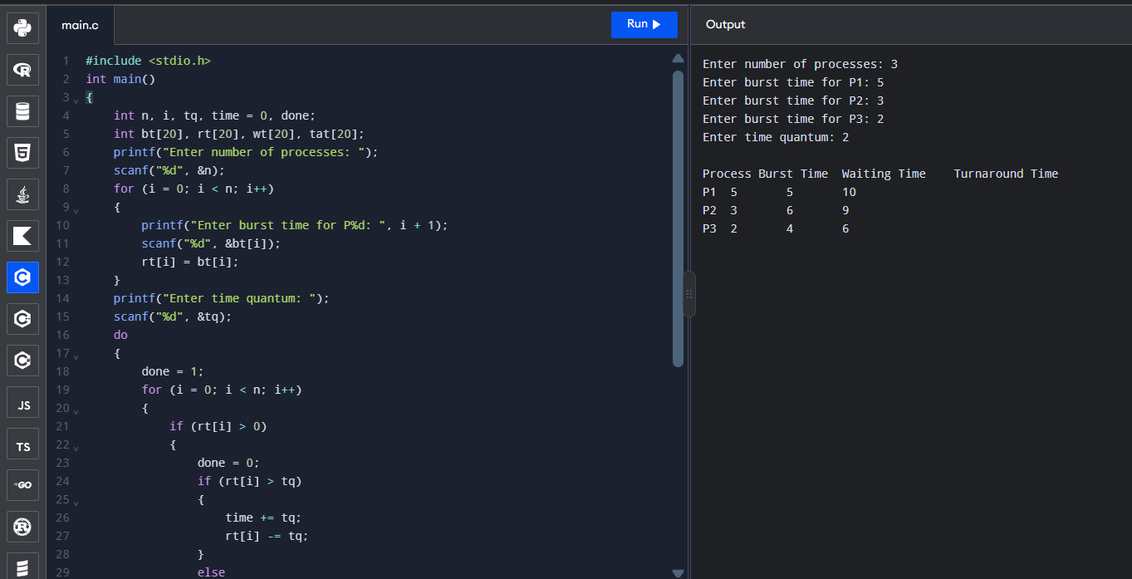

RESULT:
Thus, the Round Robin CPU Scheduling algorithm was successfully implemented in C, and the waiting time and turnaround time of each process were calculated.

